**Installation Instructions:**

1. Start with powering on the raspberry pi with monitor and keyboard input access.
2. Before any programs can run, some drivers and systems will have to be installed.
   1. CUPS
   2. Gutenprint
   3. Python3
3. CUPS Installation:
   1. At the terminal, enter the following command to begin installation of CUPS:



* 1. Type Y and press Enter.
  2. Enter the next command:

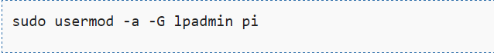

* 1. Open the file path /etc/cups/cupsd.conf in a text editor of choice.
  2. Inside the file, look for the section with the 2 lines:

# Only listen for connections from the local machine

Listen localhost:631

* 1. Comment out the “Listen localhost:631” and edit as the following:

# Only listen for connections from the local machine

# Listen localhost:631

Port 631

* 1. Scroll down further in the file until you see the “Location” sections and add the following bolded text:

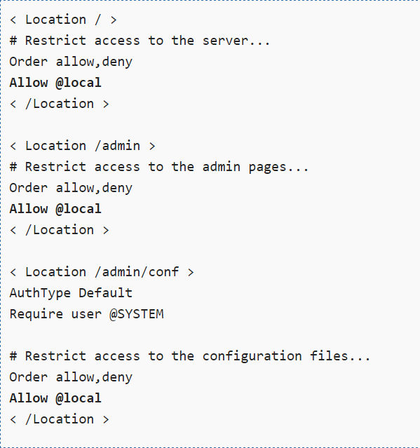

* 1. To finish install restart the CUPS Server with the following command:

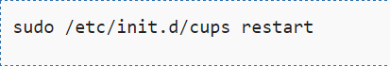

1. Gutenprint Installation:
   1. At the terminal, enter the following commands to begin installation of Gutenprint:

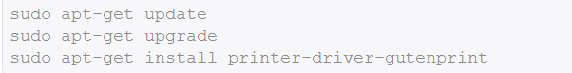

1. Python3 Installation:
   1. At the terminal, enter the following commands to begin installation of Python3:

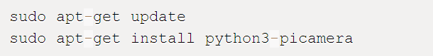

**ICEPOS User Interface Manual**

Following is the full user interface of the ICEPOS system. It is designed for ease of use while on the road making a delivery.

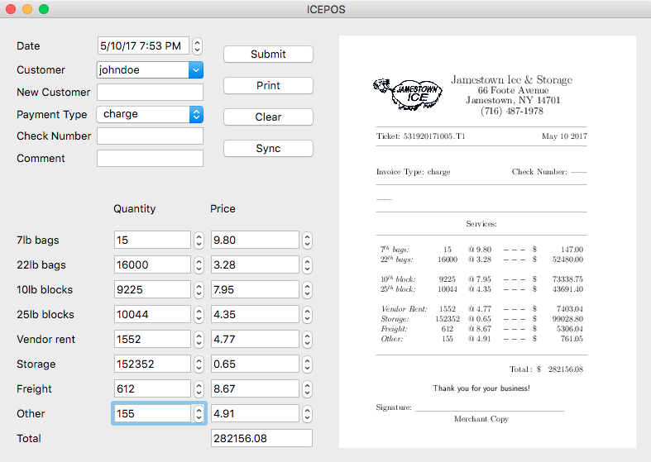

The user will begin by verifying the date.

The date is pre-populated with the current date.

From there the user will either select an existing

customer or enter a new customer. If the

user needs to enter a new customer they

should do so by typing the new customer’s

name into the textbox field labeled

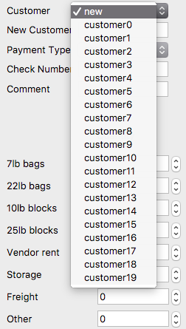“New Customer.”

Illustration of customer drop down selection:

When a customer is selected, values from the form will be cleared and will be automatically set to a zero standard.

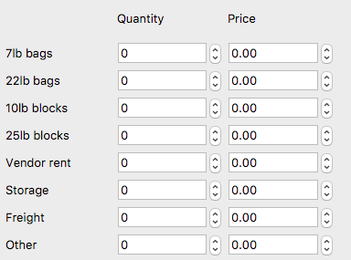

The user will then select the payment type from the drop down menu labeled “Payment Type.” There are only three options in this category: Check, Cash, Credit.

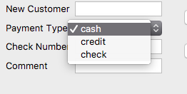

If the customer is using a check, the driver shall enter the Check Number in the text box that is labeled “Check Number”.

Macintosh HD:Users:plowmanleah:Desktop:Screen Shot 2017-04-03 at 8.33.02 PM.png

Note that there is an additional textbox below the “Check Number” textbox for comments about the transaction.

The user shall then move to the second half of the form to implement details about the transaction with the customer.

There is a textbox for each of the products sold, for driver convenience to simply enter the product total.



As the driver is inputting values into the form, the total will automatically be calculated for the driver.

Macintosh HD:Users:plowmanleah:Desktop:Screen Shot 2017-04-03 at 8.20.49 PM.pngThe first of these next three buttons is the submit button. The submit button should be selected when the driver has finished filling out the form. This will send the ticket information into the queue (as shown in the next image).

The print button should be selected when the driver is ready to hand a receipt to the customer. This will generate two receipts; one for the driver and one for the customer.



The clear button should be used when the driver needs to start from scratch with the form. It removes all of the values that are currently typed into the form to show a blank form.

Shown additionally on this screen is the “Sync” button. The “Sync” button allows the driver to send all of the transactions for the day into the home office, when he or she returns for the day.

The print button will allow the user to print the ticket which will be generate as follows:



There will be a mirrored image of this image above that allows the driver to keep one copy of the receipt for him or herself, and an additional receipt to go to the customer.

**Legacy Documentation**

commit 6289ce02fd415c18a227ee84f15a1b5b06291630

Author: pi <pi@gmail.com>

Date: Thu May 11 02:27:41 2017 +0000

added raspberry pi command log

commit e3558d80e47199365b1b8d921ab195802ae5a232

Author: Ranuka <rmanamendra@gmail.com>

Date: Wed May 10 21:54:46 2017 -0400

updated driver ui

commit 62e4725a3170d72c38e428bea96f9ceaa62bb3ba

Author: Ranuka <rmanamendra@gmail.com>

Date: Wed May 10 21:41:32 2017 -0400

changes from demo, added embedded ticket view

commit 779018c82cda5ab40e417e5e5ad9889272e2fdb3

Author: Ranuka <rmanamendra@gmail.com>

Date: Wed May 10 20:10:27 2017 -0400

added sanitize input logic for name and comment parsing

commit 672e67161e07225a480242f89922be7cdafc28a7

Author: Ranuka <rmanamendra@gmail.com>

Date: Wed May 10 20:09:44 2017 -0400

added python lib requirements

commit 17088e5fc0c8e888cca9f1ed739c4577dbcf852e

Author: Ranuka <rmanamendra@gmail.com>

Date: Wed May 10 19:55:45 2017 -0400

added screen

commit f9cd3d4a0b47141a25ce76989f27566fc4a7ba51

Author: Ranuka <rmanamendra@gmail.com>

Date: Sun May 7 18:06:32 2017 -0400

.desktop file path fix

commit 0074ae8489833a8469bff39efef4127431b9a551

Author: Ranuka <rmanamendra@gmail.com>

Date: Sun May 7 18:00:40 2017 -0400

more changes..

commit e71fc2de160309731d2bcfbbcf7b63787eb67360

Author: Ranuka <rmanamendra@gmail.com>

Date: Sun May 7 17:42:44 2017 -0400

changes to start.sh

commit 97378603c58749dd665e89a7eff2e868dbde617d

Author: Ranuka <rmanamendra@gmail.com>

Date: Sun May 7 17:31:00 2017 -0400

added test desktop file

commit cb3a4c74112a652b88ec7f50c3d723b6cb5648fd

Author: Ranuka <rmanamendra@gmail.com>

Date: Sun May 7 17:02:18 2017 -0400

updated .desktop file, changed pdf path

commit cf79b860e814878babfe329365f04139c404c466

Author: Ranuka <rmanamendra@gmail.com>

Date: Sun May 7 16:20:59 2017 -0400

added two versions of the app, one for office use, one for drivers; retained original paths

commit 4547dfb90f6ff7b8c2686fd47914183f07fce498

Author: Ranuka <rmanamendra@gmail.com>

Date: Thu Apr 27 18:54:25 2017 -0400

changed path

commit 41b70d23bcef13f77eb03a7a1a274f3ba73d8d5c

Author: Ranuka <rmanamendra@gmail.com>

Date: Thu Apr 27 18:51:58 2017 -0400

added display pdf support

commit e037f8692ea31649b495d1eed74b6854e89bead5

Author: Ranuka <rmanamendra@gmail.com>

Date: Thu Apr 27 18:42:03 2017 -0400

changed print sequence order

commit 6dcea932736466bcb28c2bcd94efb3e183f35a43

Author: Ranuka <rmanamendra@gmail.com>

Date: Thu Apr 27 18:22:48 2017 -0400

added list conversion since keys() returns an obj and not a list in python3

commit a4c9af836022ff1e4e7baf81915bc96b2f49c2c2

Author: Ranuka <rmanamendra@gmail.com>

Date: Thu Apr 27 17:08:17 2017 -0400

added more missing code

commit 40a13d6026a965309c8334841a7ffaeed9dae6be

Author: Ranuka <rmanamendra@gmail.com>

Date: Thu Apr 27 17:05:27 2017 -0400

added missing code

commit b98f48130b37b399a78067683f4aff1887cf548b

Author: Ranuka <rmanamendra@gmail.com>

Date: Tue Apr 18 18:54:59 2017 -0400

added customer filtering support

commit bfb060a1a04f346ace846a30048e2c921adb79f9

Author: Ranuka <rmanamendra@gmail.com>

Date: Tue Apr 18 18:54:35 2017 -0400

added directory checking/creation before app start

commit e9cd1aeedca6517874a08c1f4090d31b5e62262d

Author: Ranuka <rmanamendra@gmail.com>

Date: Tue Apr 18 18:54:00 2017 -0400

gave customers more unique names to check for customer search filtering

commit 79440131f89f7dea0d9ac61345fbeaeebefe89d4

Author: Ranuka <rmanamendra@gmail.com>

Date: Tue Apr 18 18:53:34 2017 -0400

added latex pdf generation

commit e1b6a6f3195c69afd23d2b1b00d2a97ad5c71e30

Author: Ranuka <rmanamendra@gmail.com>

Date: Tue Apr 18 18:53:00 2017 -0400

fixed import err

commit f62923e9f8eaf9f6ece5235d3a3a53b36702b342

Author: John Chrispell <john.chrispell@iup.edu>

Date: Wed Apr 12 09:26:55 2017 -0400

added Template for the printed ticket

commit fb6b2c35eee5f7fec590bb6eaf3cc7eb450090c4

Author: Ranuka <rmanamendra@gmail.com>

Date: Sun Apr 2 23:15:51 2017 -0400

init commit